**ABSTRACT**: -

This report provides a detailed overview of the development and implementation of the "Intellect Quiz" website. The project is built using HTML, CSS, and JavaScript (Angular.js) to create an interactive and user-friendly quiz platform. The report covers the problem statement, proposed system, module descriptions, source code, screen snapshots, and the conclusion.

**PROBLEM STATEMENT: -**

Online learning and assessment platforms are gaining popularity in the current digital landscape. However, many available quiz applications lack customization, interactive UI, and responsiveness. The "Intellect Quiz" project aims to bridge this gap by providing a user-friendly, visually appealing, and efficient quiz platform where users can test their knowledge interactively.

**PROPOSED SYSTEM:** -

The proposed system is a web-based quiz application that allows users to take quizzes on various topics. The system is designed with:

* A structured HTML layout to organize quiz questions and options.
* A CSS-styled user interface for an engaging experience.
* JavaScript (Angular.js) for dynamic content updates and quiz logic.
* A responsive design that adapts to different screen sizes.

**MODULE DESCRIPTION: -**

1. **User Interface Module**: Handles the layout and structure using HTML and CSS.
2. **Quiz Logic Module**: Manages quiz questions, answer validation, and scoring using JavaScript.
3. **Styling and Animation Module**: Uses CSS to enhance the visual appeal and provide smooth transitions.
4. **Data Handling Module**: Ensures interaction between the user and the quiz, displaying real-time responses.

**SOURCE CODE : -**

The project comprises three primary files:

* **Intellect Quiz.html**: Contains the structure of the quiz, including question placeholders and answer options.
* <!DOCTYPE html>
* <html lang="en" ng-app="quizApp">
* <head>
* <meta charset="UTF-8">
* <meta name="viewport" content="width=device-width, initial-scale=1.0">
* <title>AngularJS Quiz App</title>
* <script src="https://ajax.googleapis.com/ajax/libs/angularjs/1.8.2/angular.min.js"></script>
* <link href="https://fonts.googleapis.com/css2?family=Poppins:wght@400;600&display=swap" rel="stylesheet">
* <link rel="stylesheet" href="style.css" type="text/css">
* <script src="Angular.js"></script>
* </head>
* <body ng-controller="QuizController">
* <header>
* <h1>Intellect Quiz</h1><br><br><br>
* </header>
* <div class="quiz-container" ng-show="!quizStarted" ng-show="!quizOver">
* <h2>SELECT A GENRE</h2>
* <div class="genre-images">
* <div ng-repeat="genre in genres" ng-click="startQuiz(genre)">
* <img ng-src="{{ genre + '.png' }}" alt="{{ genre }}" class="genre-image">
* <p>{{ genre }}</p>
* </div>
* </div>
* </div>
* <div class="quiz-container" ng-show="quizStarted && !quizOver">
* <div class="progress-bar">
* <div class="progress" style="width: {{(currentQuestion / questions.length) * 100}}%;"></div>
* </div>
* <div class="timer">Time Left: {{ timeLeft }}s</div>
* <div class="question">{{ questions[currentQuestion].question }}</div>
* <ul class="options">
* <li ng-repeat="option in questions[currentQuestion].options"
* ng-click="selectAnswer(option)"
* ng-class="{'correct': answered && option === questions[currentQuestion].answer, 'incorrect': answered && selectedAnswer === option && option !== questions[currentQuestion].answer}">
* {{ option }}
* </li>
* </ul>
* <button ng-click="nextQuestion()" ng-disabled="!answered">Next</button>
* </div>
* <!-- Quiz Over Container -->
* <div class="quiz-over-container" ng-show="quizOver && !nameSubmitted">
* <h2 class="h2">Quiz Over!</h2>
* <p class="p">Your score: {{ score }} / {{ questions.length }}</p>
* <div>
* <br>
* <input class="a" type="text" ng-model="userName" placeholder="Enter your name" /><br>
* <button ng-click="submitName()">Submit</button>
* </div>
* </div>
* <!-- Leaderboard Section -->
* <div class="leaderboard" ng-show="showLeaderboard">
* <h2>Leaderboard</h2>
* <table>
* <thead>
* <tr>
* <th>Rank</th>
* <th>Name</th>
* <th>Score</th>
* </tr>
* </thead>
* <tbody>
* <tr ng-repeat="entry in leaderboard | orderBy:'-score'">
* <td>{{ $index + 1 }}</td>
* <td>{{ entry.name }}</td>
* <td>{{ entry.score }}</td>
* </tr>
* </tbody>
* </table><br>
* <button ng-click="restartQuiz()">Restart Quiz</button>
* </div>
* </body>
* </html>
* **style.css**: Defines the appearance of the quiz, such as font styles, button designs, and layouts.
* body {
* font-family: 'Poppins', sans-serif;
* text-align: center;
* margin: 20px;
* background: #36454F;
* color: white;
* }
* header h1 {
* font-size: 36px;
* font-weight: 600;
* color: white;
* text-shadow: 2px 2px 4px rgba(0, 0, 0, 0.3);
* }
* /* Quiz Container */
* .quiz-container {
* width: 1000px;
* height: 420px;
* margin: auto;
* padding: 30px;
* border-radius: 15px;
* background: #36454F;
* box-shadow: 0px 10px 30px white;
* animation: fadeIn 0.5s ease;
* }
* /* animation for the quiz container */
* @keyframes fadeIn {
* from { opacity: 0; transform: translateY(20px); }
* to { opacity: 1; transform: translateY(0); }
* }
* /* Genre Images */
* .genre-images {
* display: flex;
* justify-content: space-around;
* margin-top: 20px;
* }
* .genre-images div {
* text-align: center;
* cursor: pointer;
* transition: transform 0.2s ease;
* }
* .genre-images div:hover {
* transform: scale(1.1);
* }
* .genre-image {
* width: 200px;
* height: 200px;
* border-radius: 10px;
* object-fit: cover;
* box-shadow: 0px 5px 15px rgba(0, 0, 0, 0.2);
* }
* /* Progress Bar */
* .progress-bar {
* width: 100%;
* background-color: rgba(255, 255, 255, 0.3);
* border-radius: 10px;
* margin-bottom: 20px;
* overflow: hidden;
* }
* .progress {
* height: 10px;
* background: linear-gradient(135deg, white, #FFFFF0);
* border-radius: 10px;
* transition: width 0.3s ease;
* }
* /* Timer */
* .timer {
* font-size: 25px;
* color: #dedddd;
* font-weight: bold;
* margin-bottom: 15px;
* animation: pulse 1s infinite;
* margin-left: -800px;
* }
* /* animation for the timer */
* @keyframes pulse {
* 0% { transform: scale(1); }
* 50% { transform: scale(1.1); }
* 100% { transform: scale(1); }
* }
* /* Question and Options */
* .question {
* font-size: 20px;
* margin-bottom: 20px;
* font-weight: 600;
* color: white;
* }
* .options {
* list-style: none;
* padding: 0;
* }
* p {
* color: white;
* }
* .options li {
* margin: 10px auto;
* width: 300px;
* justify-content: center;
* padding: 12px;
* border-radius: 20px;
* background: rgba(255, 255, 255, 0.8);
* color: #333;
* transition: background 0.3s ease, transform 0.2s ease;
* }
* .options li:hover {
* background: rgba(255, 255, 255, 1);
* transform: translateX(5px);
* cursor: pointer;
* }
* .options li.correct {
* background: #28a745;
* border: #28a745;
* color: white;
* }
* .options li.incorrect {
* background: #dc3545;
* color: white;
* }
* /* Buttons */
* button {
* margin-top: 15px;
* padding: 12px 25px;
* border: 2px solid white;
* background: linear-gradient(135deg, #36454F, #444242);
* color: white;
* font-size: 16px;
* cursor: pointer;
* border-radius: 25px;
* transition: transform 0.2s ease, box-shadow 0.2s ease;
* }
* button:hover:not(:disabled) {
* transform: translateY(-2px);
* box-shadow: 0px 5px 15px rgba(0, 0, 0, 0.2);
* }
* button:disabled {
* background: #ccc;
* cursor: not-allowed;
* }
* /* Quiz Over Container */
* .quiz-over-container {
* width: 400px;
* height: 300px;
* margin: auto;
* padding: 30px;
* border-radius: 15px;
* background: #ffffff; /* Solid background */
* box-shadow: 0px 10px 30px white;
* animation: fadeIn 0.5s ease;
* color: #36454F; /* Text color */
* }
* /* style for the p and h2 tag of the quiz over container */
* .p{
* color: #36454F;
* font-size: 20px;
* }
* .h2{
* font-size: 40px;
* color: #36454F;
* }
* /* Leaderboard Section */
* .leaderboard {
* margin-top: 20px;
* font-size: 20px;
* justify-content: center;
* }
* .leaderboard table {
* width: 800px;
* border-collapse: collapse;
* margin: auto;
* margin-top: 10px;
* }
* .leaderboard th, .leaderboard td {
* padding: 10px;
* border: 1px solid white;
* }
* .leaderboard th {
* background-color: #32383e;
* }
* /* Style for Input */
* input {
* height: 30px;
* width: 300px;
* font-size: 20px;
* }
* **Angular.js**: Implements the interactive functionality of the quiz, such as question navigation, answer validation, and score calculation.
* var app = angular.module('quizApp', []);
* app.controller('QuizController', function($scope, $interval) {
* $scope.genres = ["General Knowledge", "Mathematics", "Science"];
* $scope.leaderboard = []; // Array to store leaderboard data
* $scope.userName = ""; // User's name
* $scope.nameSubmitted = false; // Flag to check if name is submitted
* $scope.showLeaderboard = false; // Flag to show/hide leaderboard
* var timer;
* var questionBank = {
* "General Knowledge": [
* { question: "What is the capital of France?", options: ["Madrid", "Berlin", "Paris", "Rome"], answer: "Paris" },
* { question: "Who wrote 'Hamlet'?", options: ["Shakespeare", "Hemingway", "Tolstoy", "Austen"], answer: "Shakespeare" },
* { question: "What is the hardest natural substance on Earth?", options: ["Gold","Iron","Diamond","Quartz"], answer: "Diamond"},
* { question: "Which country is known as the Land of the Rising Sun?", options:["China","Japan","South Korea","Thailand"], answer:"Japan"},
* { question: "Which country is famous for inventing the Olympic Games?", options:["Italy","France","Greece","Germany"], answer: "Greece"}
* ],
* "Mathematics": [
* { question: "What is 5 + 3?", options: ["5", "15", "12", "8"], answer: "8" },
* { question: "What is 12 / 4?", options: ["2", "3", "4", "6"], answer: "3" },
* { question: "What is the area of a rectangle with length 10 cm and width 5 cm?", options: ["30 cm2","40 cm2","50 cm2","60 cm2"], answer:"50 cm2"},
* { question: "What is ³√27?", options: ["90 deg","180 deg","270 deg","360 deg"], answer:"180 deg"},
* { question: "Which shape has only one curved surface and no edges?", options: ["Cube","Cone","Sphere","Cylinder"], answer:"Sphere"}
* ],
* "Science": [
* { question: "Which planet is known as the Red Planet?", options: ["Earth", "Mars", "Jupiter", "Saturn"], answer: "Mars" },
* { question: "What is the chemical symbol for water?", options: ["O2", "CO2", "H2O", "HO"], answer: "H2O" },
* { question: "What is the powerhouse of the cell?", options:["Nuclues","Ribosome","Mitochondria","Endoplasmic Reticulum"], answer:"Mitochondria"},
* { question: "What is the pH value of pure water?", options:["5","7","9","12"], answer: "7"},
* { question: "Which element is a liquid at room temperature?", options:["Mercury","Sodium","Iron","Copper"], answer: "Mercury"}
* ]
* };
* $scope.startQuiz = function(genre) {
* $scope.questions = questionBank[genre];
* $scope.quizStarted = true;
* $scope.currentQuestion = 0;
* $scope.score = 0;
* $scope.quizOver = false;
* $scope.answered = false;
* startTimer();
* };
* function startTimer() {
* if (timer) $interval.cancel(timer);
* $scope.timeLeft = 10;
* timer = $interval(function() {
* if ($scope.timeLeft > 0) {
* $scope.timeLeft--;
* } else {
* $scope.nextQuestion();
* }
* }, 1000);
* }
* $scope.selectAnswer = function(option) {
* if (!$scope.answered) {
* $scope.answered = true;
* $scope.selectedAnswer = option;
* if (option === $scope.questions[$scope.currentQuestion].answer) {
* $scope.score++;
* }
* $interval.cancel(timer);
* }
* };
* $scope.nextQuestion = function() {
* if ($scope.currentQuestion < $scope.questions.length - 1) {
* $scope.currentQuestion++;
* $scope.answered = false;
* startTimer();
* } else {
* $scope.quizOver = true;
* }
* };
* $scope.submitName = function() {
* if ($scope.userName) {
* $scope.leaderboard.push({ name: $scope.userName, score: $scope.score });
* $scope.nameSubmitted = true;
* $scope.showLeaderboard = true; // Show leaderboard after name submission
* }
* };
* $scope.restartQuiz = function() {
* $scope.quizStarted = false;
* $scope.quizOver = false;
* $scope.nameSubmitted = false;
* $scope.showLeaderboard = false;
* $scope.userName = ""; // Reset user name
* };
* });

**SCREEN SHOTS:**

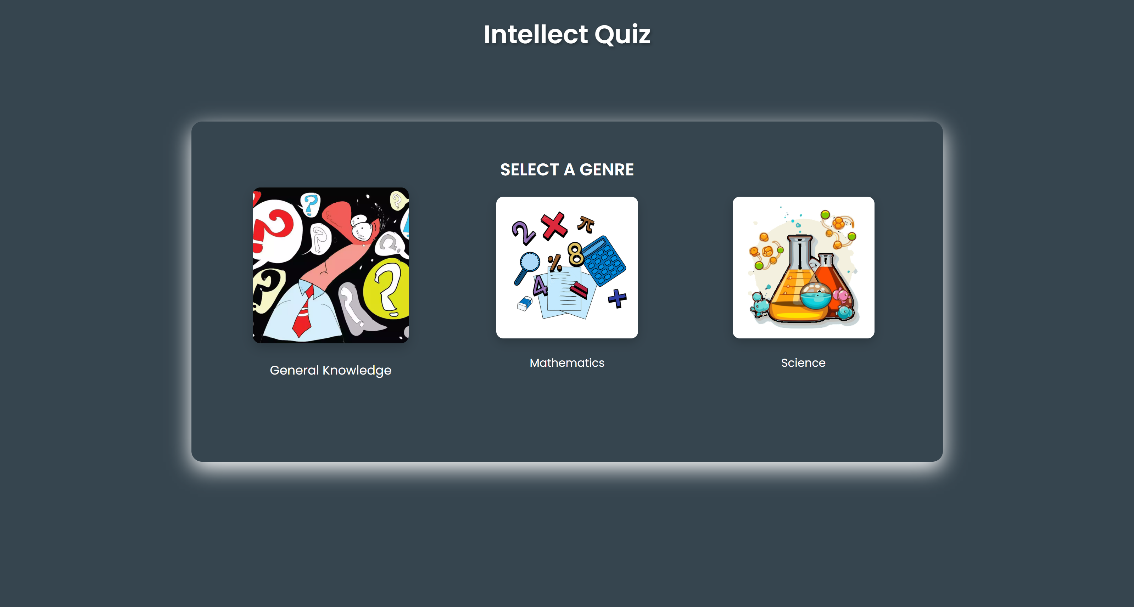

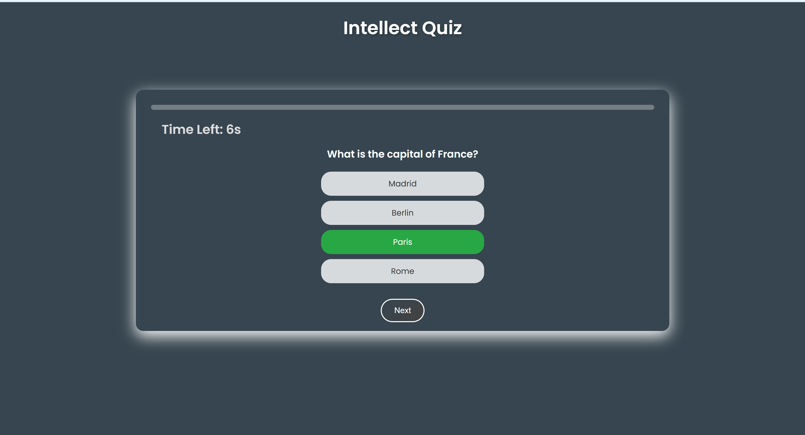

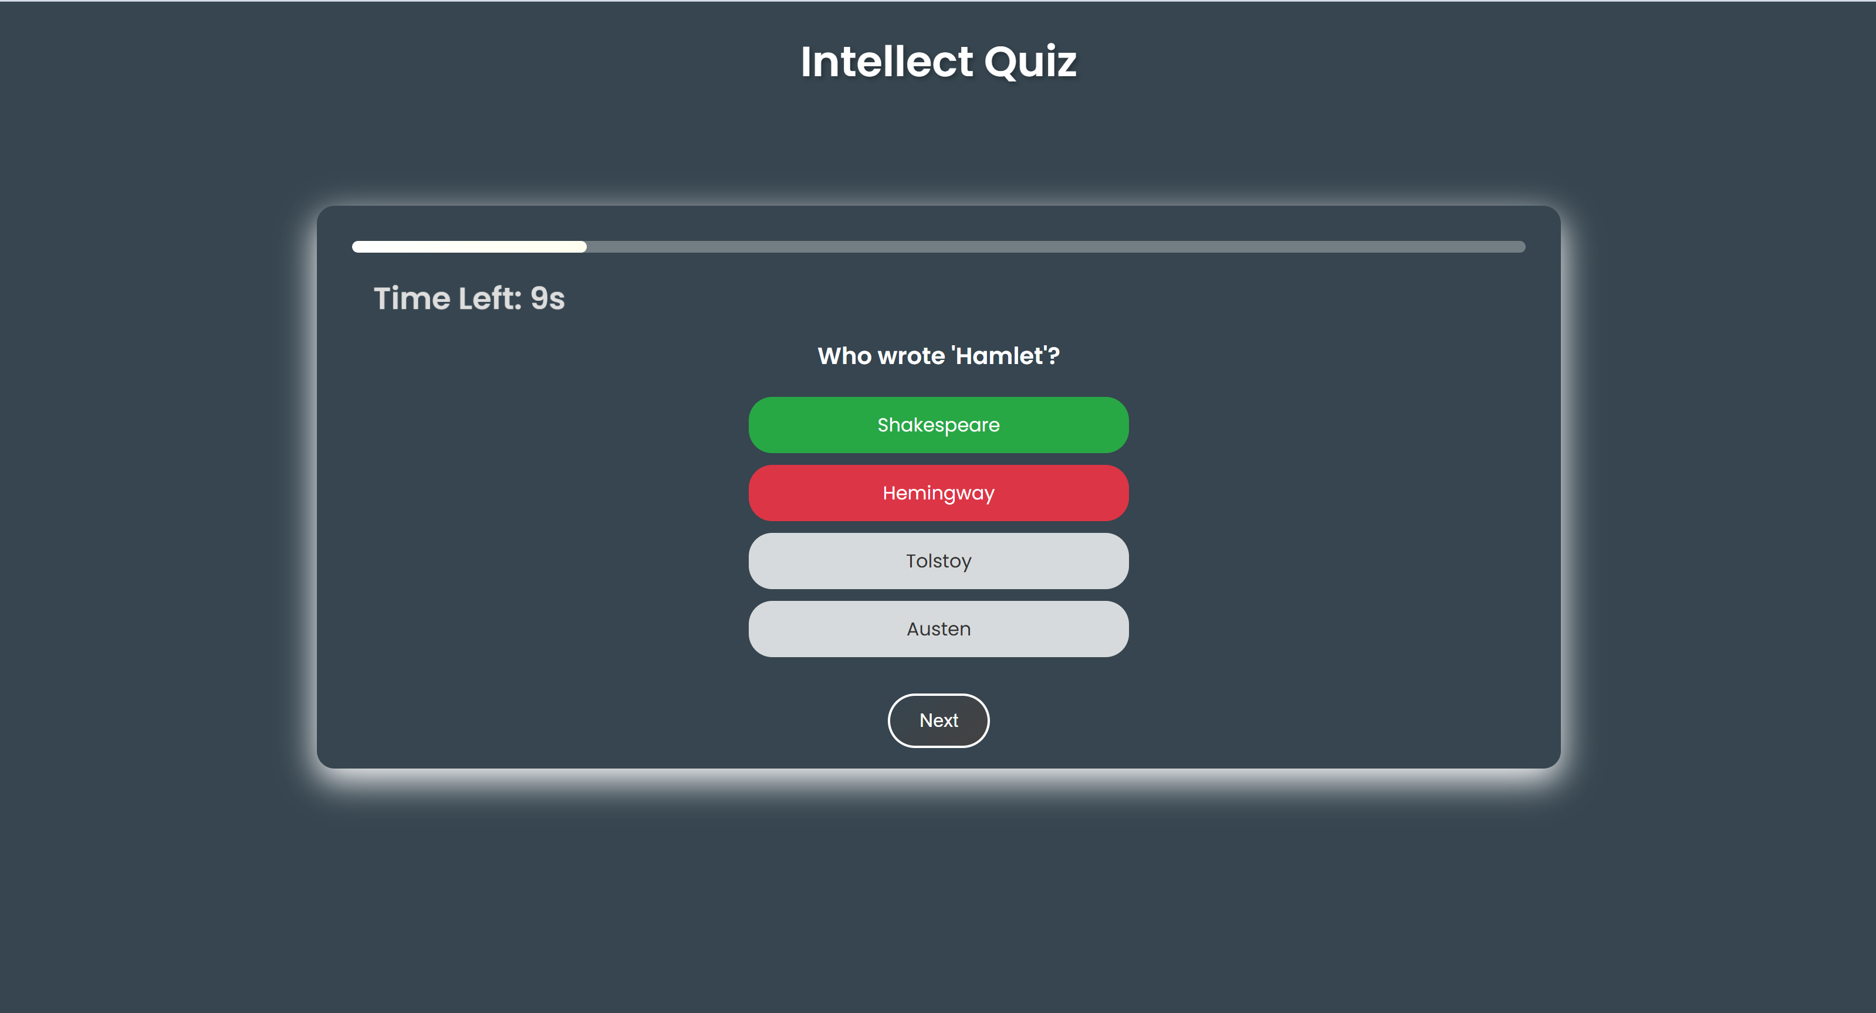

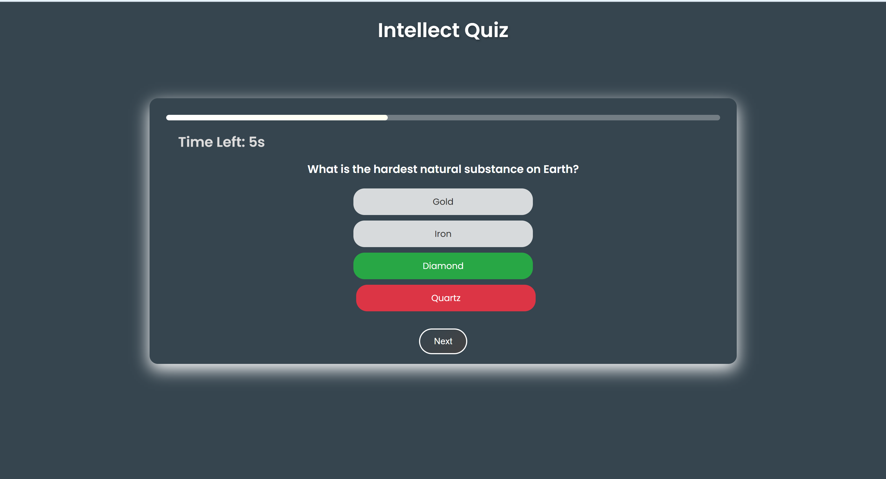

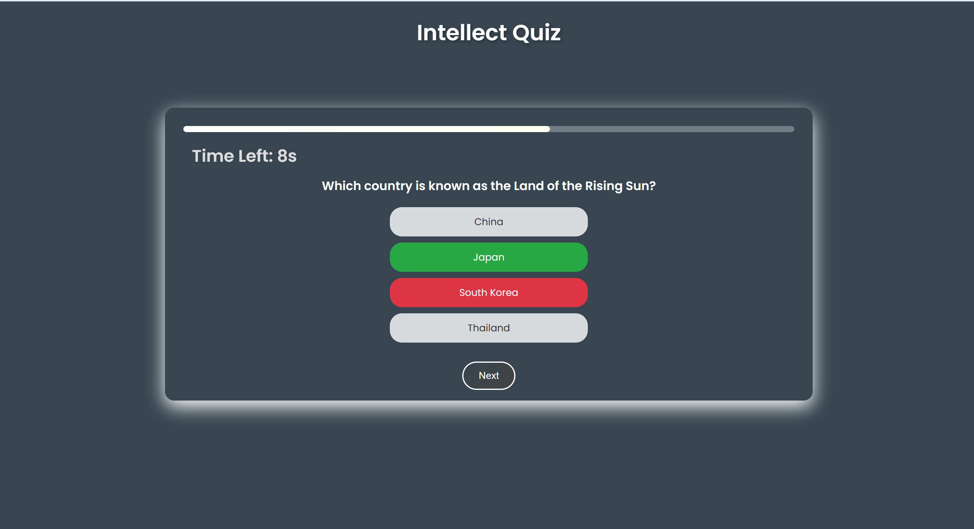

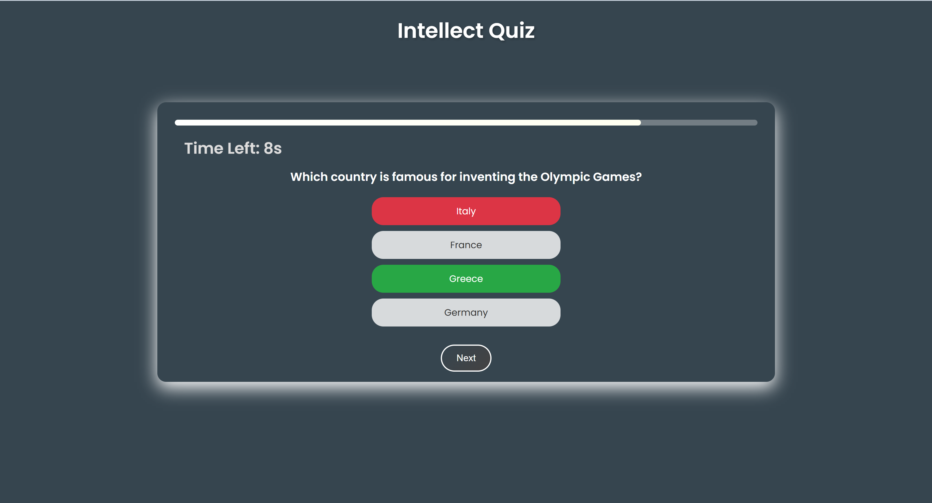

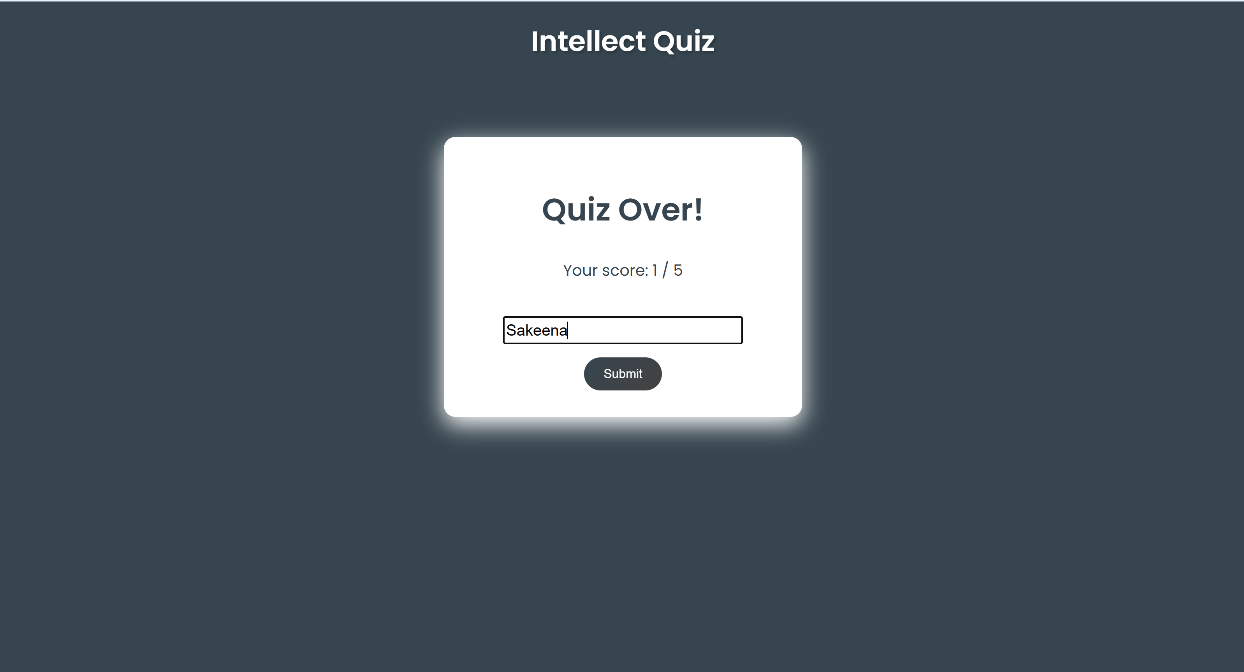

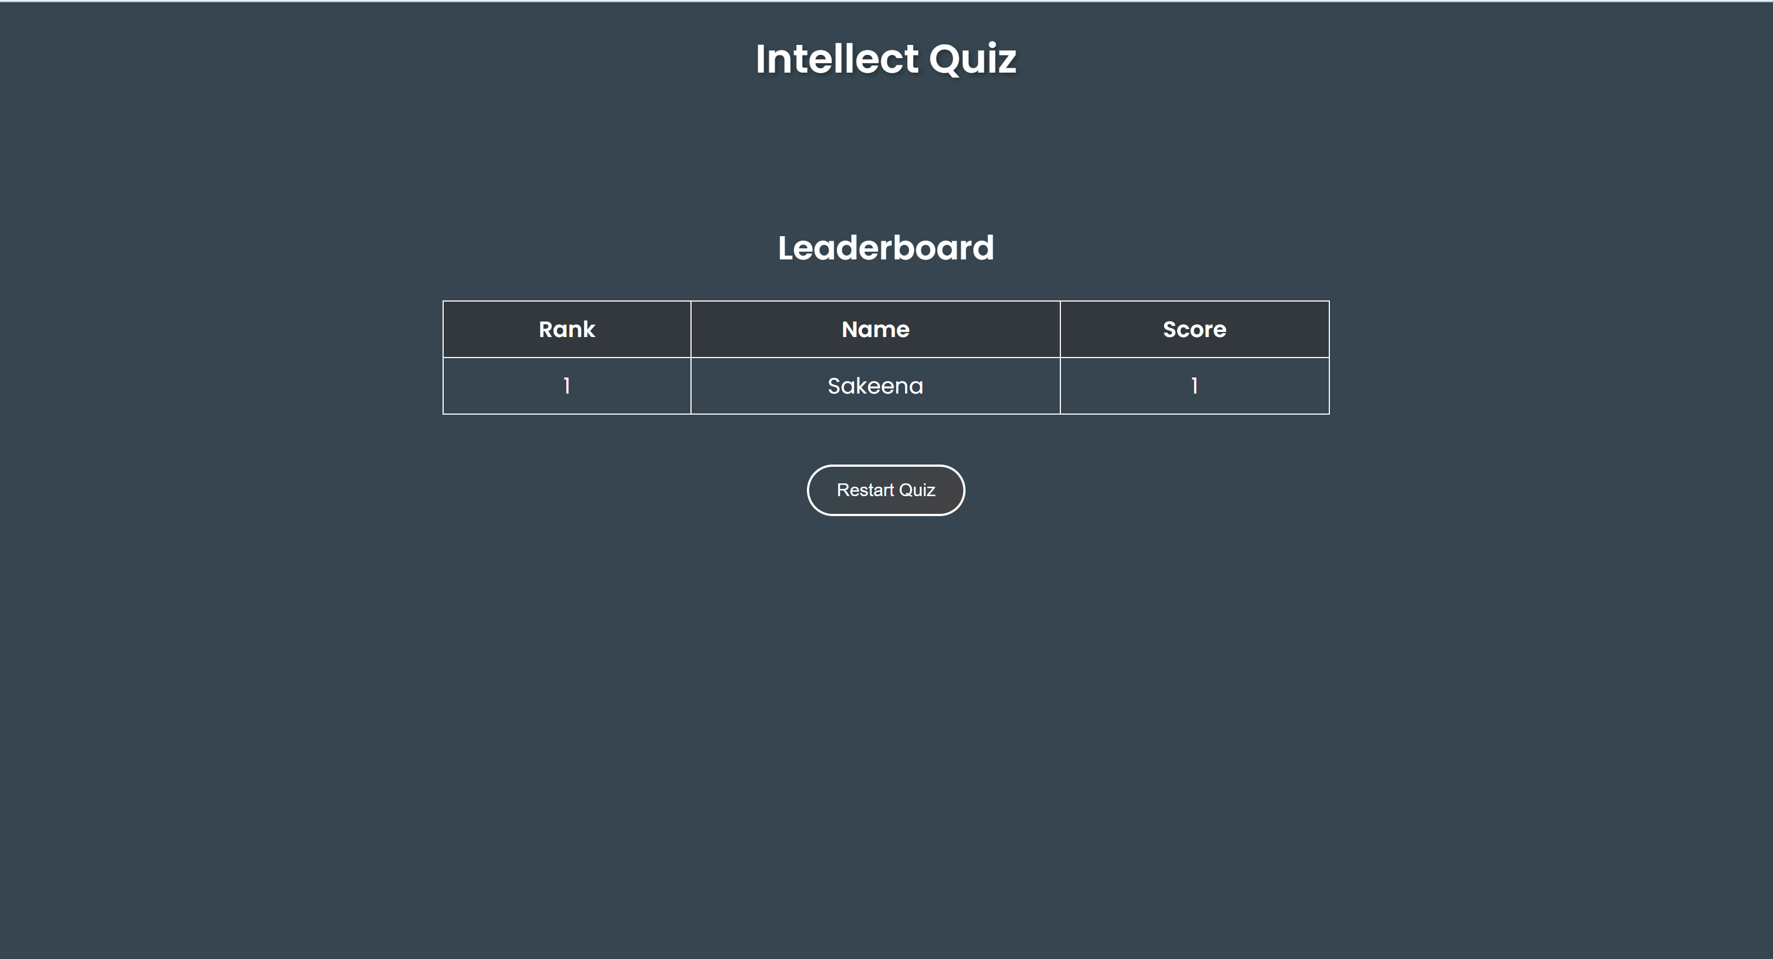

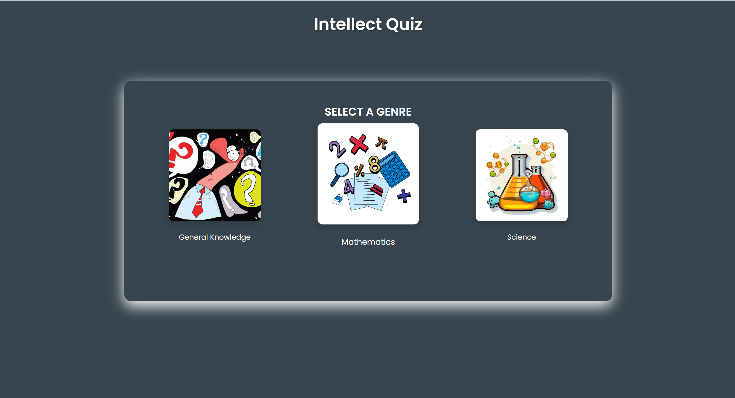

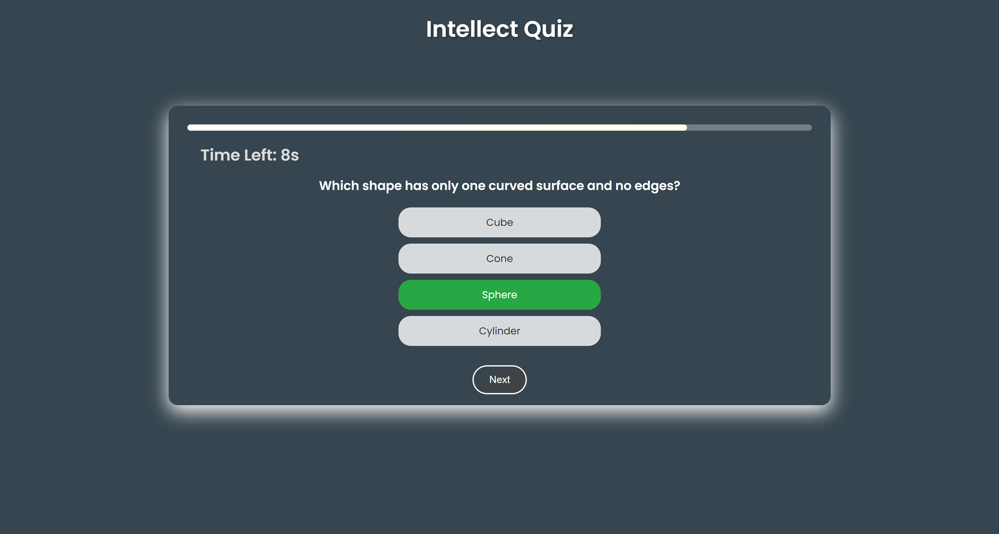

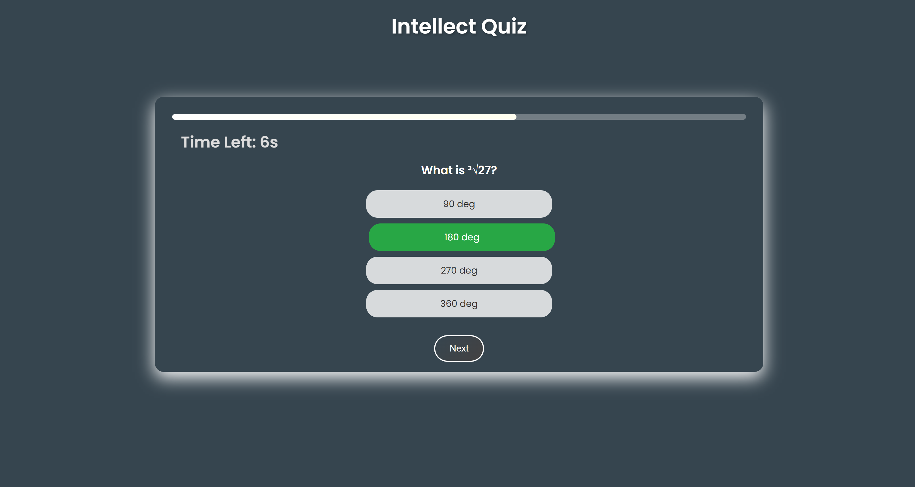

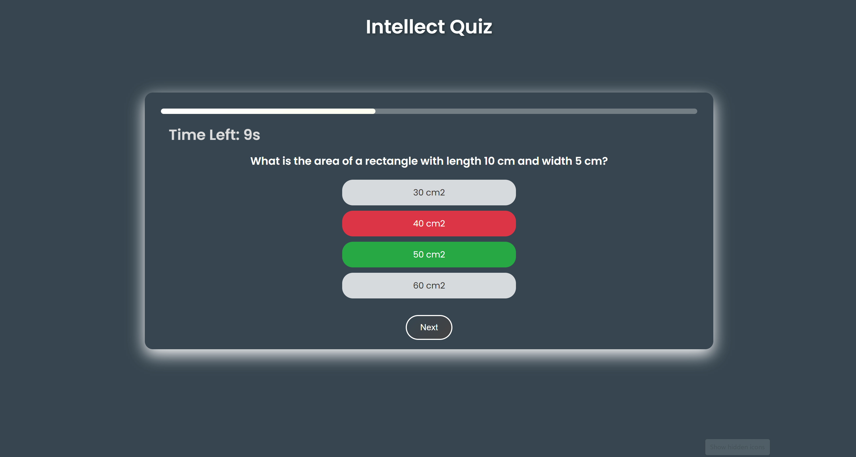

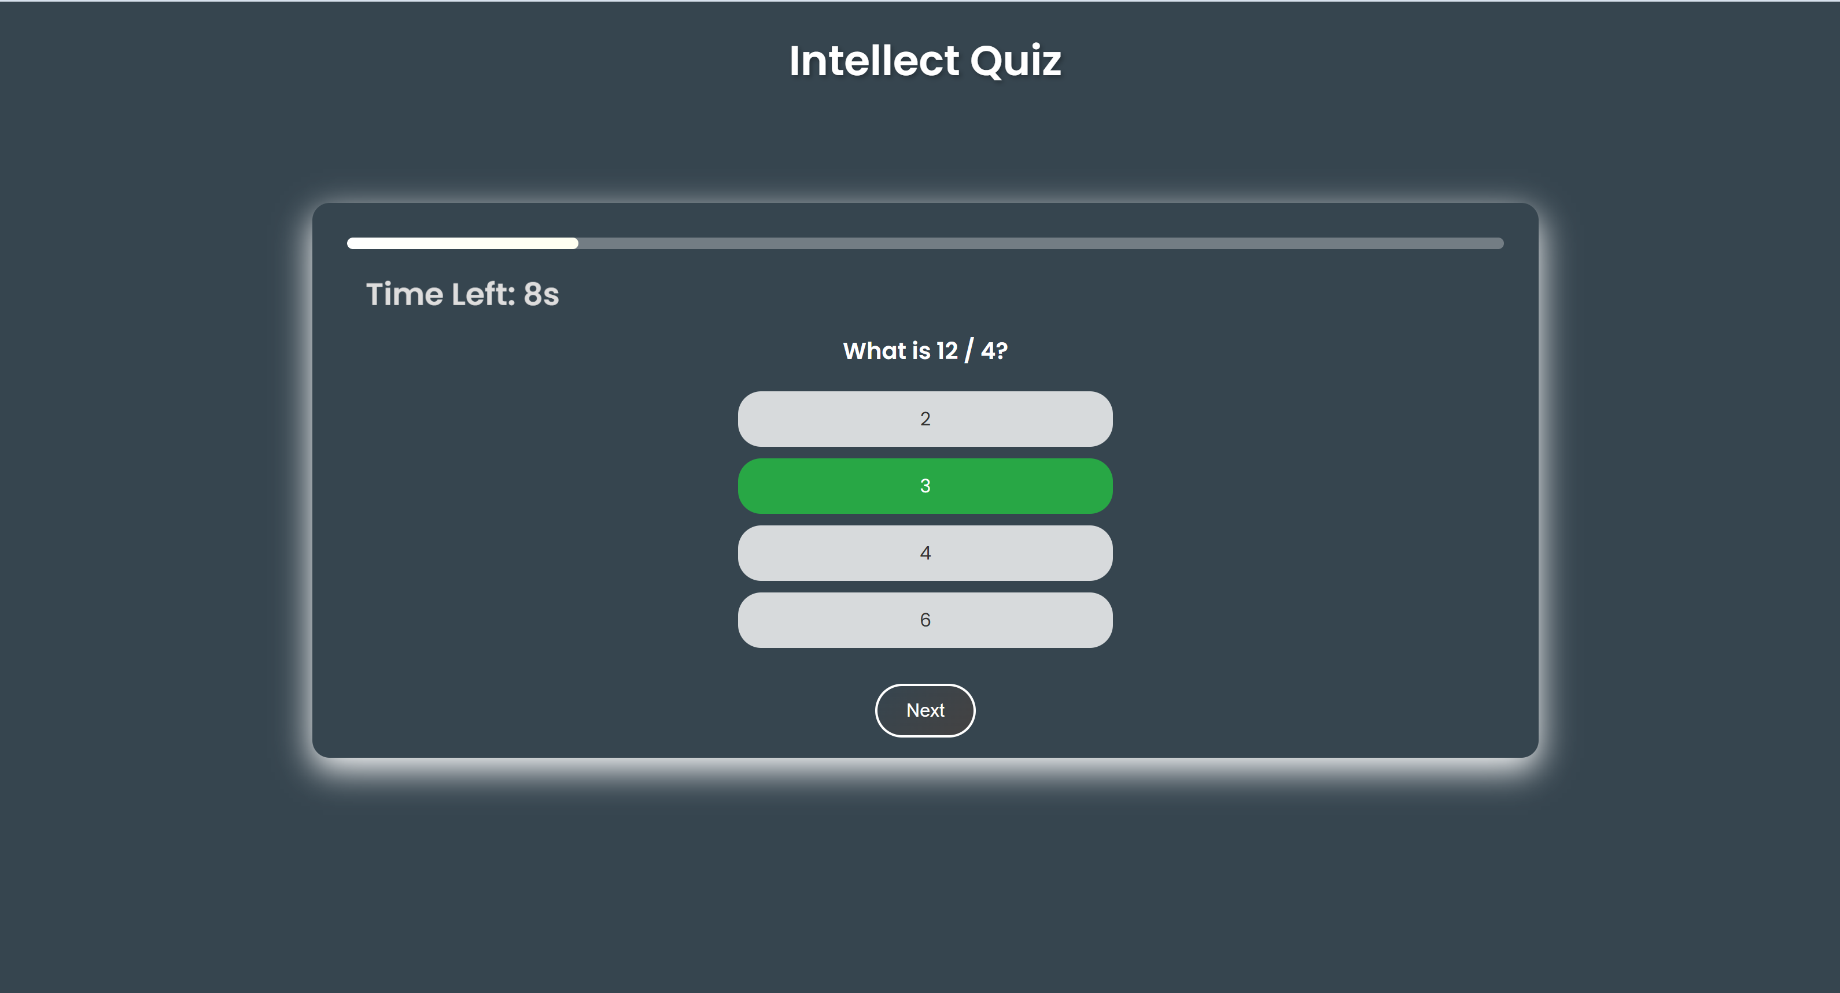

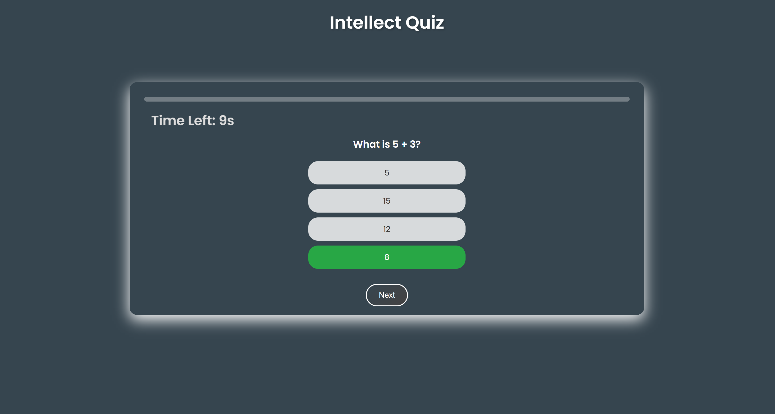

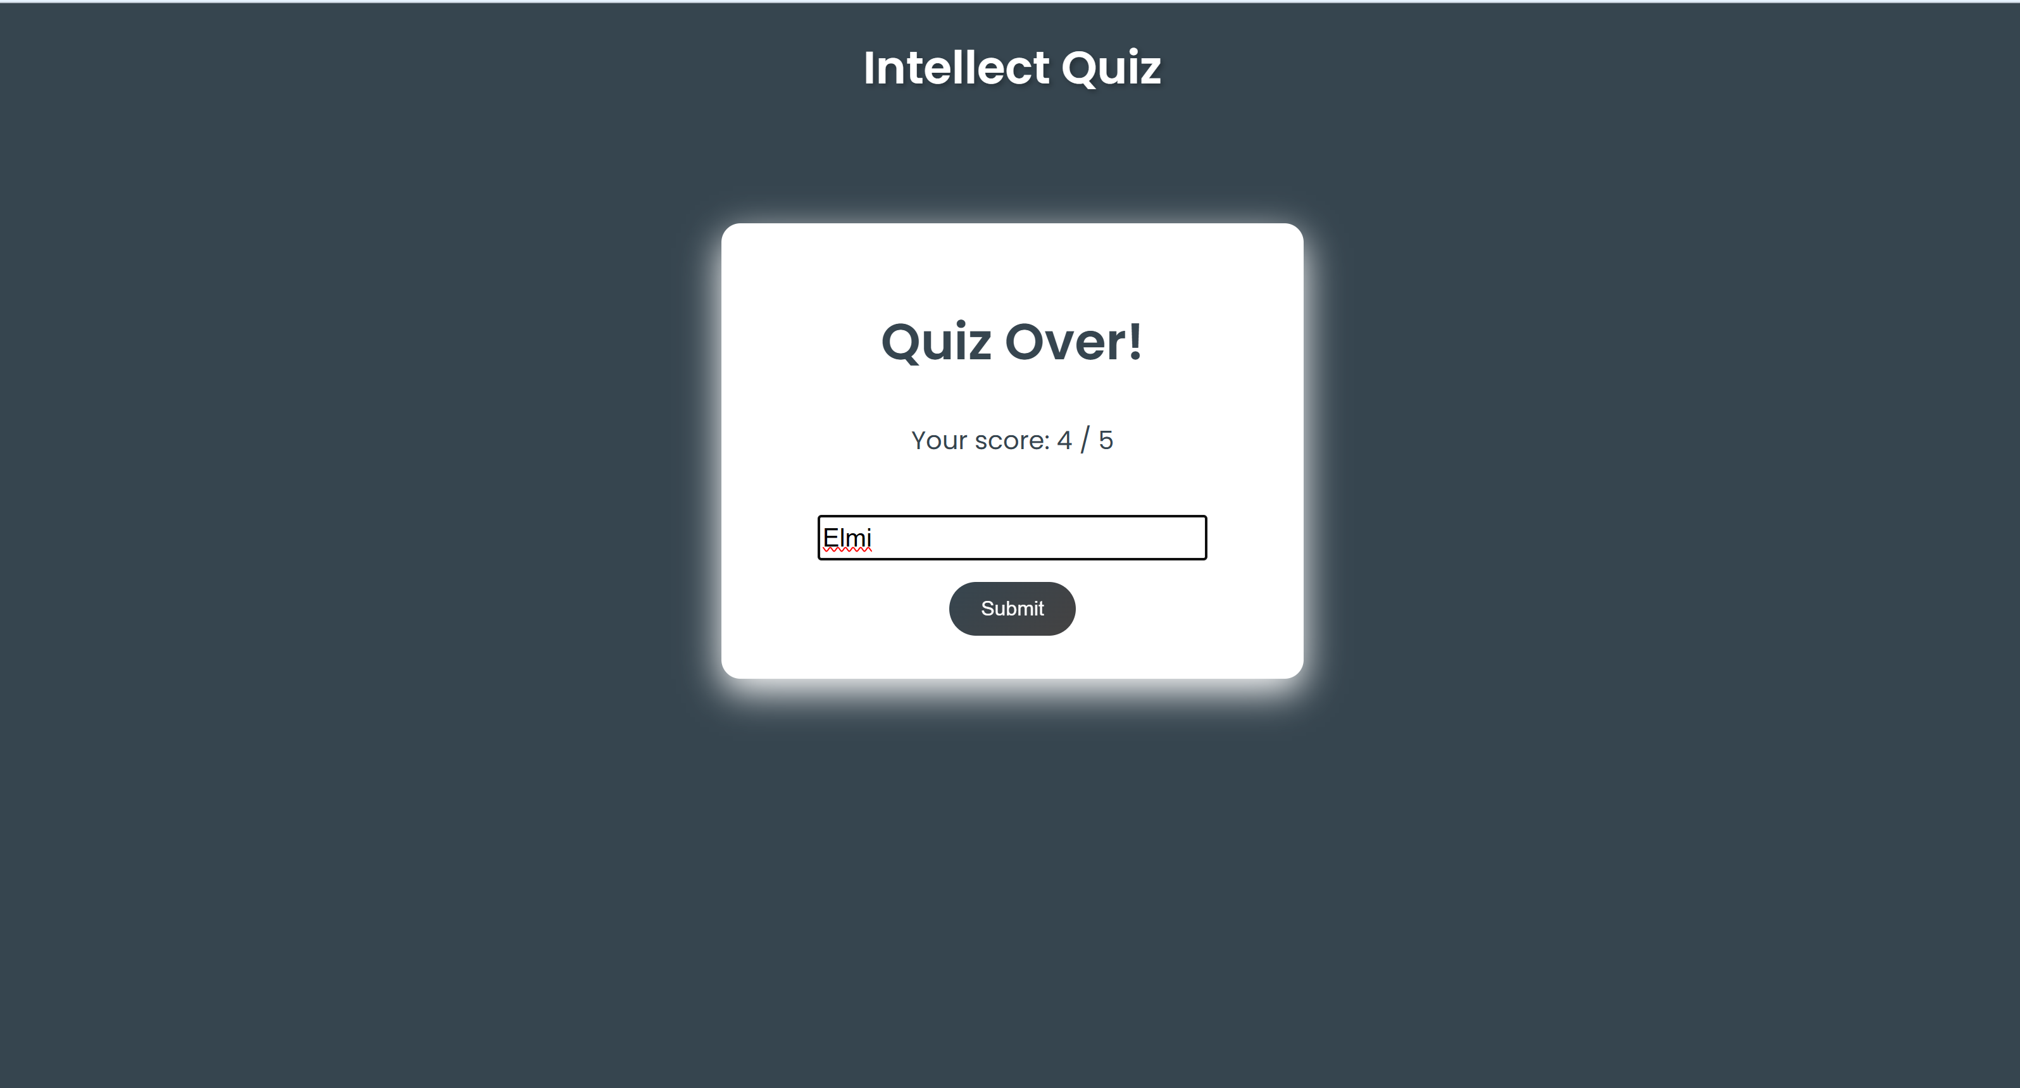

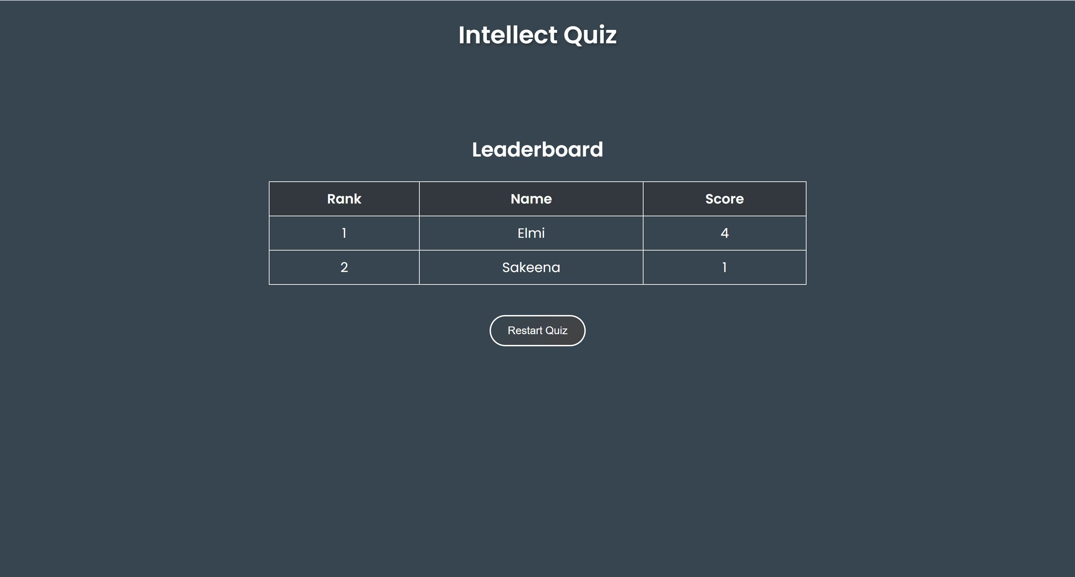

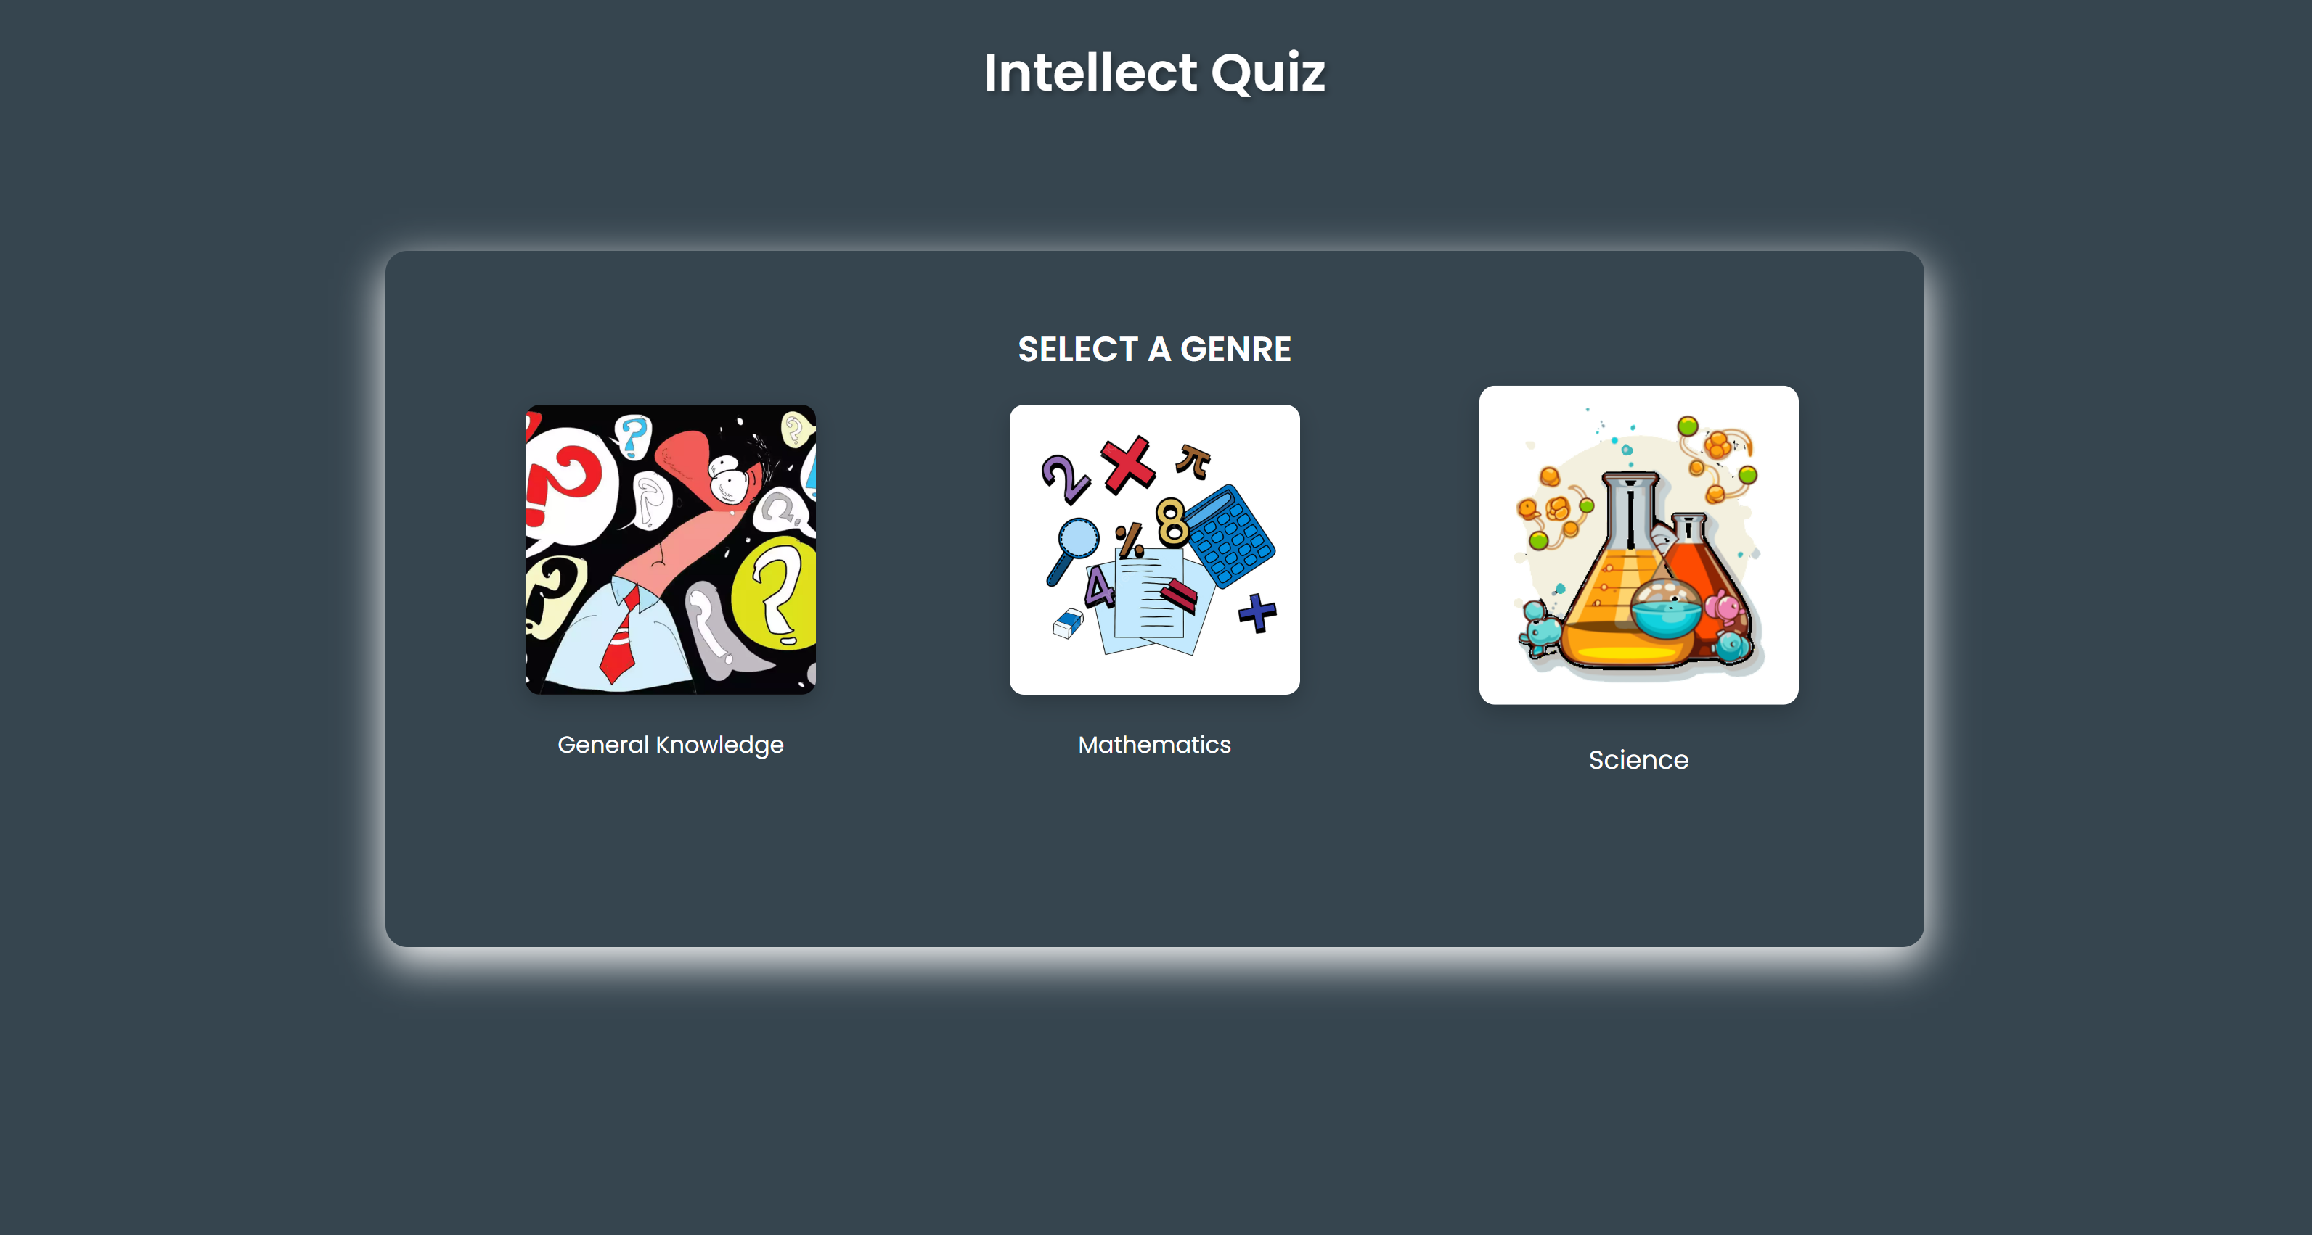

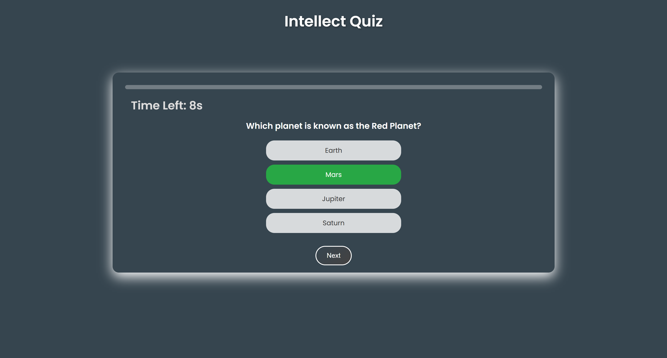

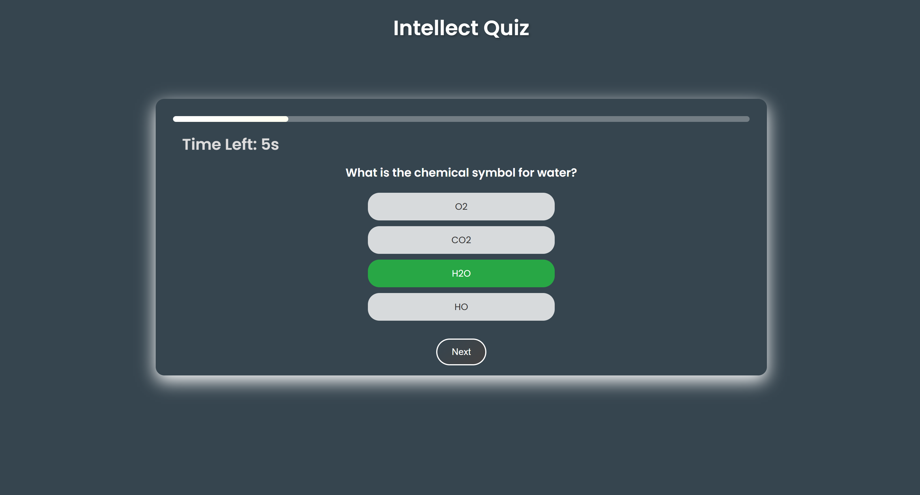

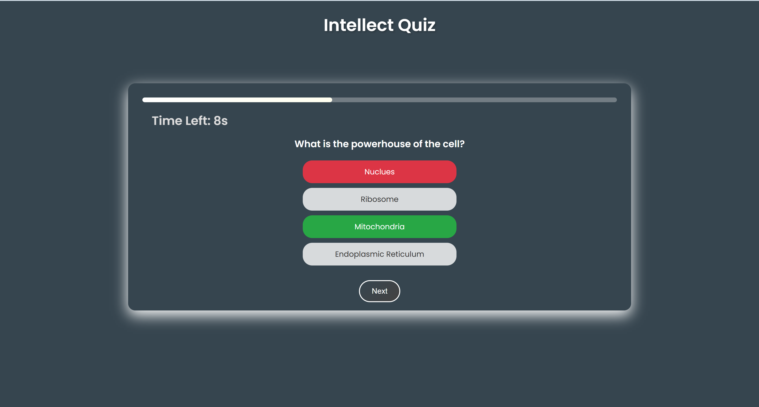

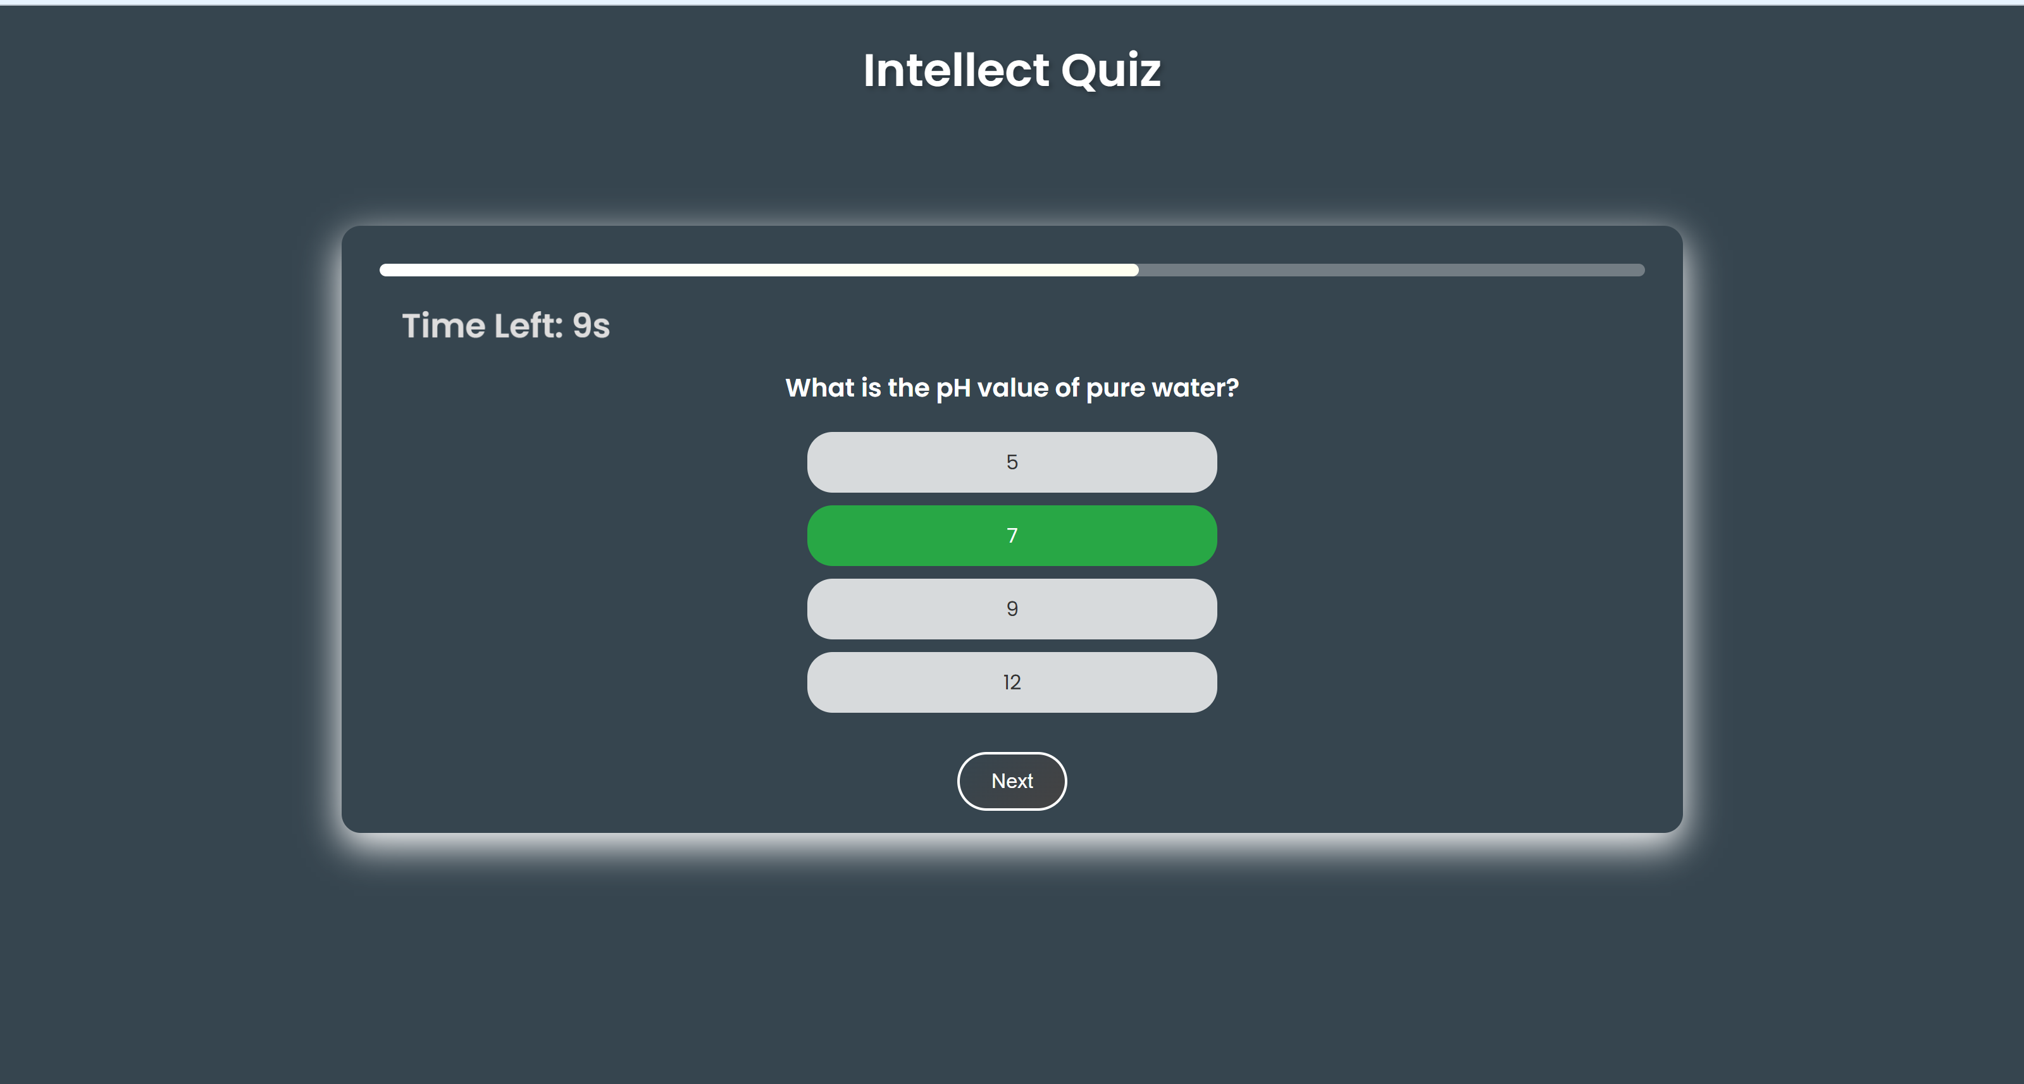

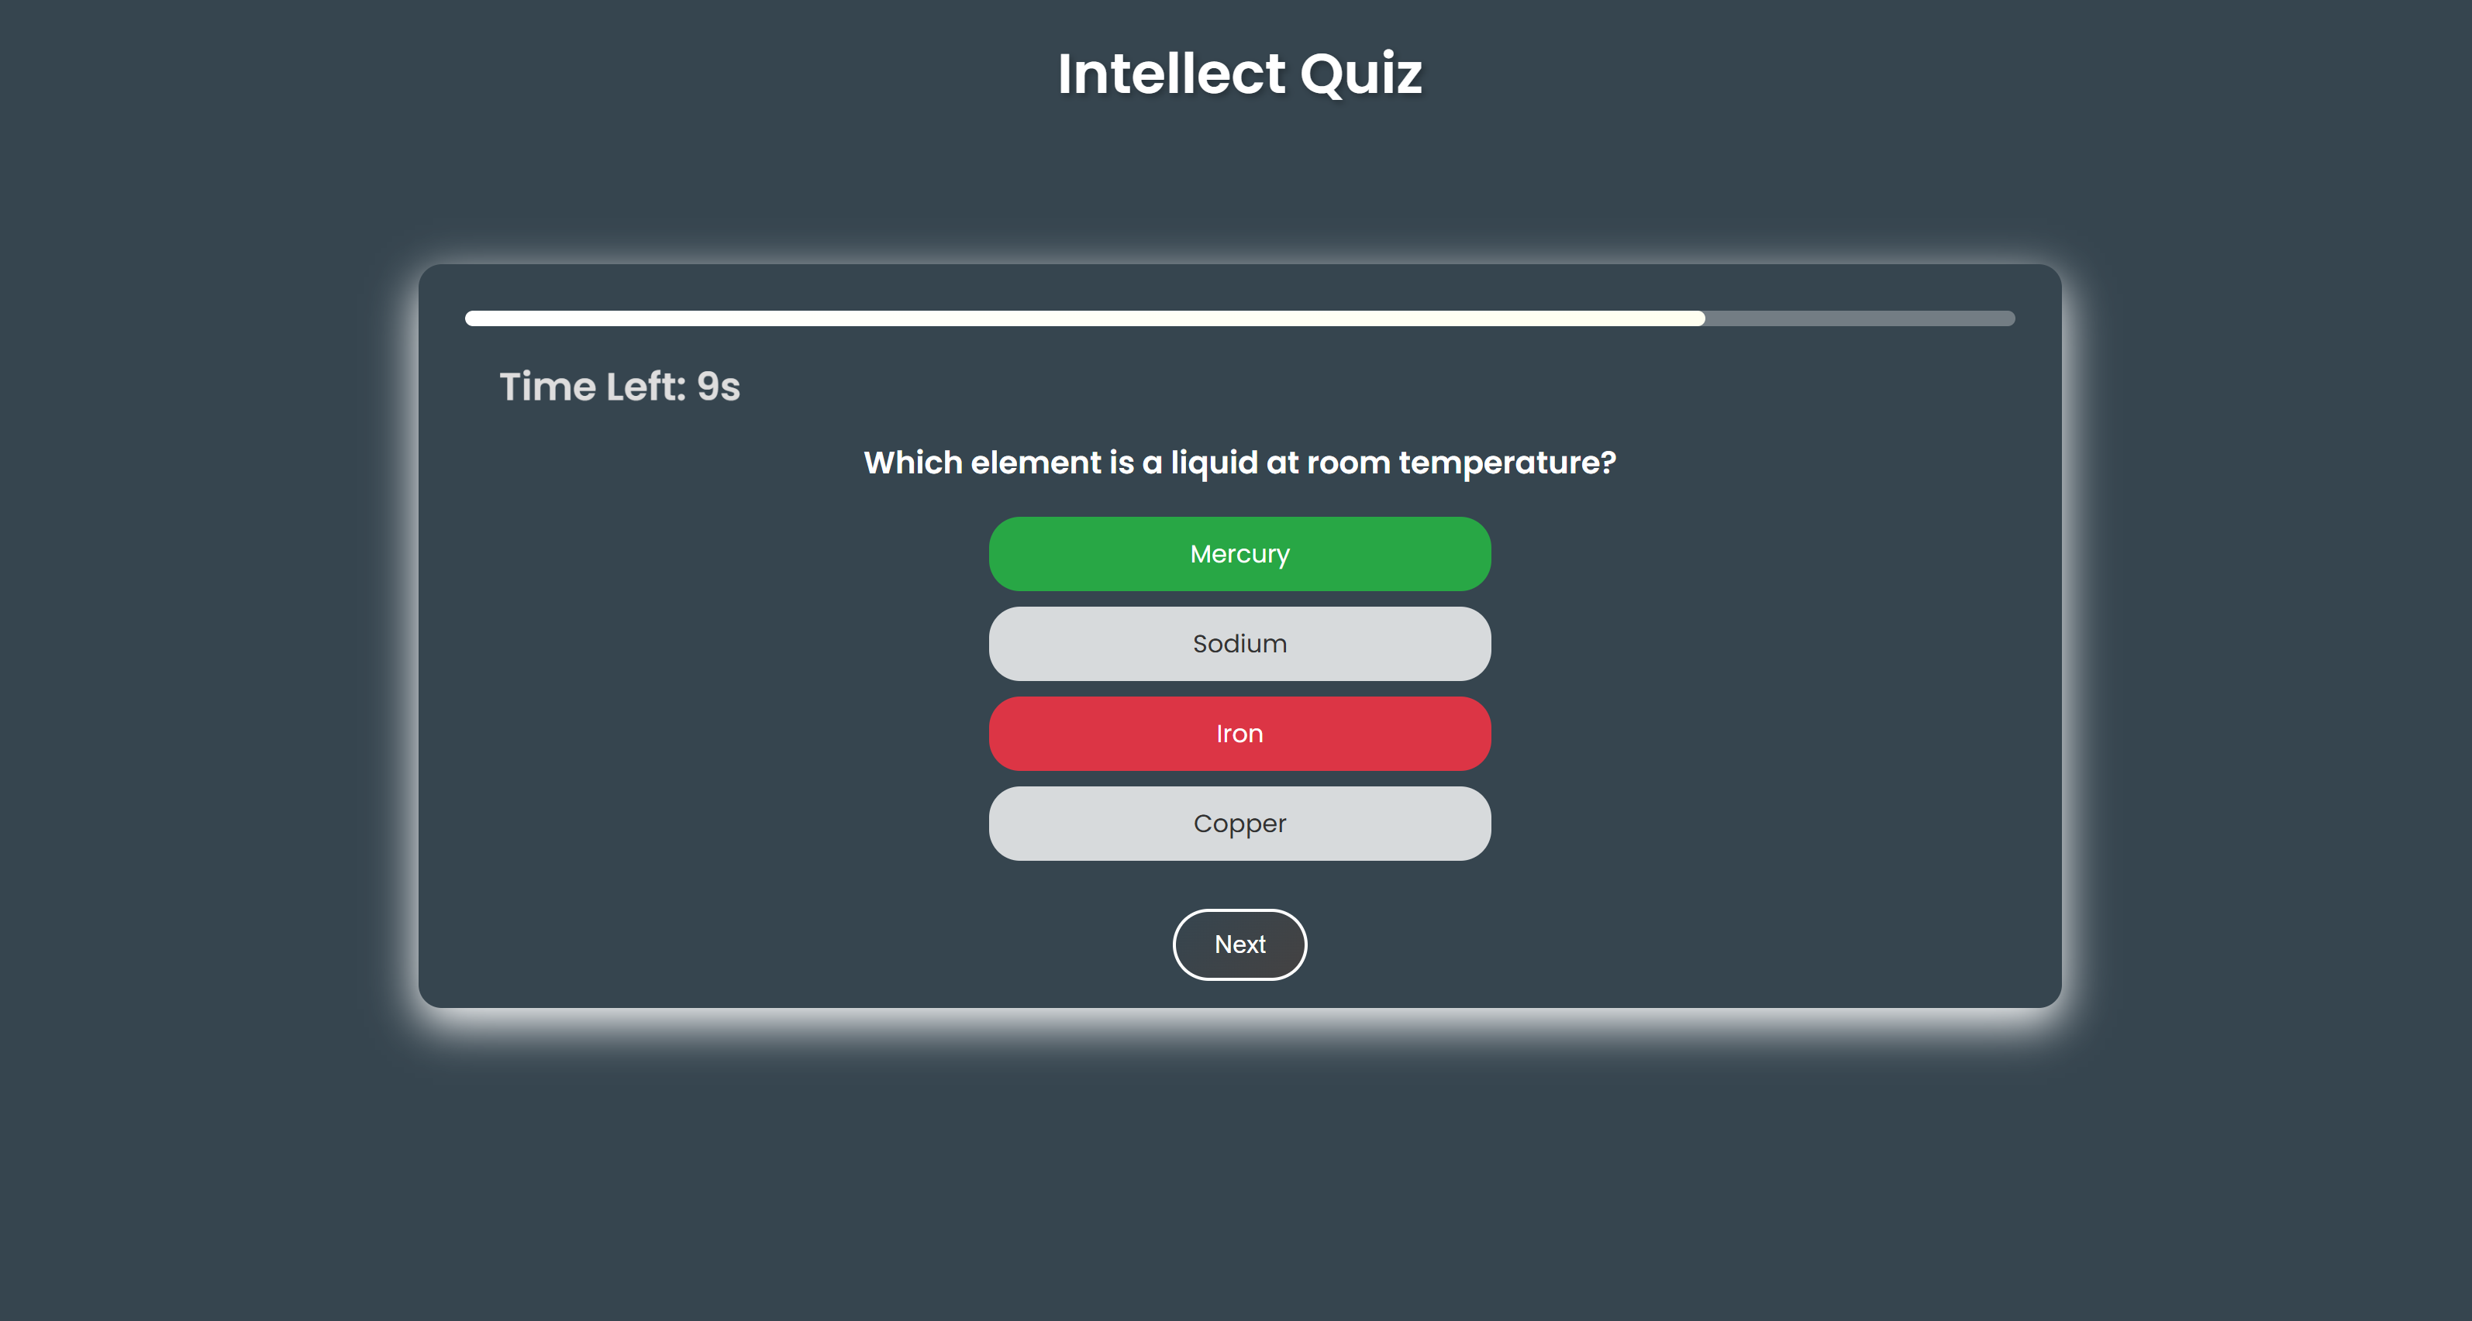

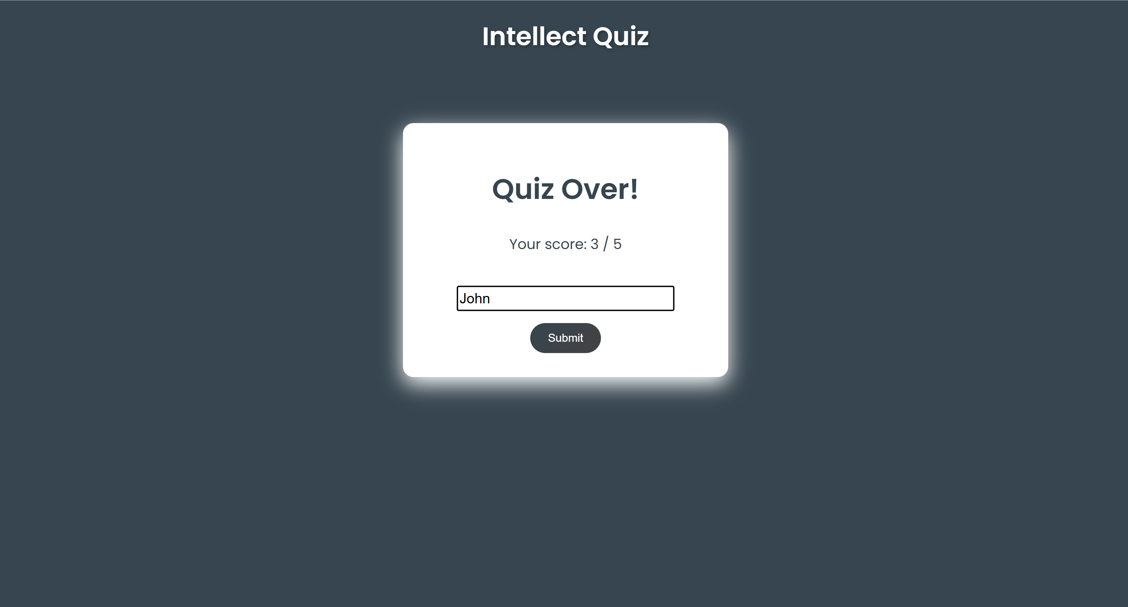

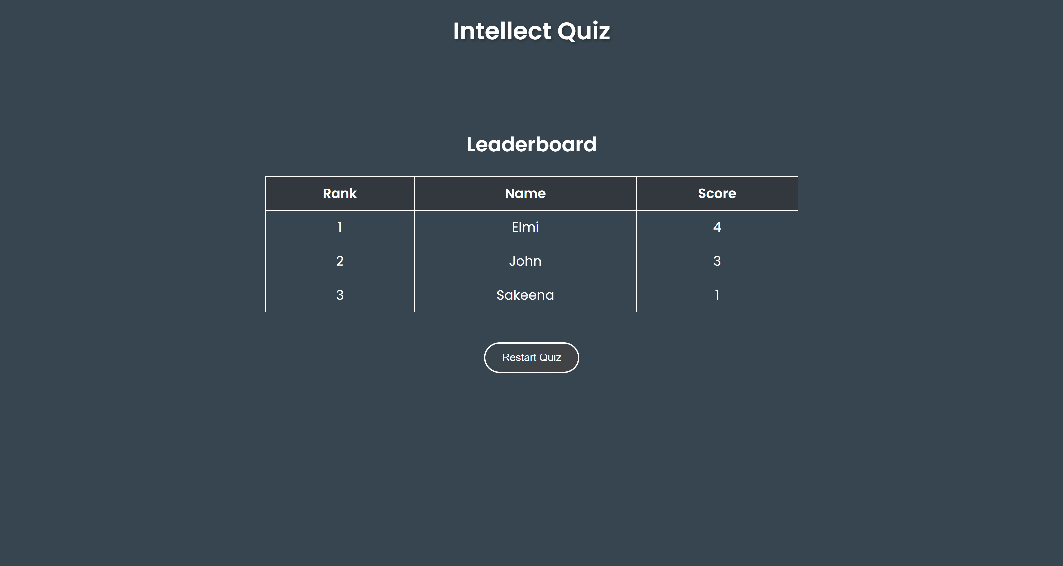

**CONCLUSION: -**

The "Intellect Quiz" project successfully delivers an interactive quiz platform that is easy to use and visually appealing. By integrating HTML, CSS, and Angular.js, the application offers a seamless user experience with dynamic content updates and engaging animations. Future improvements could include a backend database for storing user scores, multiple quiz categories, and a leaderboard feature to enhance user engagement.